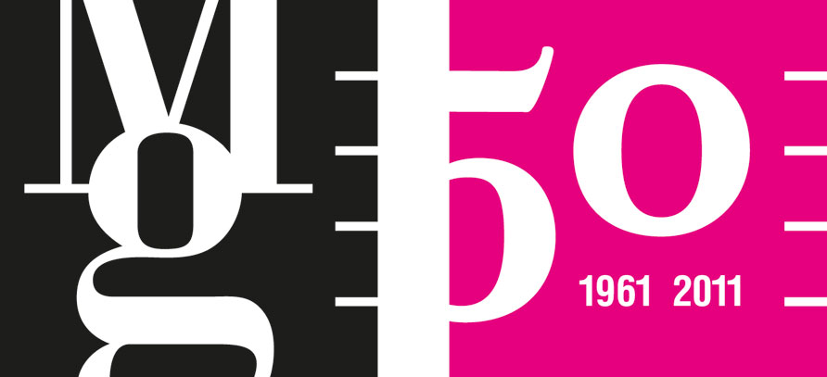Plane, Depth, Space
Perspective motifs and principles in art

Moravian Gallery in Brno
Tisková zpráva / Press Release

Pražák Palace, Husova 18, Brno
18th March – 19th June 2011
opening 17th March at 17.00

EXHIBITION AUTHOR
Petr Ingerle

SPATIAL ARRANGEMENT
Tomáš Vaněk

GRAPHIC DESIGN OF THE EXHIBITION
Jan Šerých

PRODUCTION
Veronika Jičínská, Miroslava Pluháčková

EXHIBIT RESTORATION
Alena Hejduková

INSTALLATION
Petr Kolaja, Martin Ondruš, Jiří Šujan

PROMOTION
Kateřina Pacíková, Veronika Pacíková, Martina Vašková

ACCOMPANYING PROGRAMME
Pavlína Vogelová, pavlina.vogelova@moravska-galerie.cz

GUIDED TOURS
Eva Strouhalová, da@moravska-galerie.cz

The exhibition entitled Plane, Depth, Space will introduce the visitors to the mystery of perspective, explain the approach of artists from different periods to depicting depth and space in the two-dimensional picture plane and show perspective principles and motifs that appeared in various works of art throughout art history.
The exhibition will display drawings, prints, paintings, as well as photographs, videos and spatial installations from the Baroque period, the 20th century and the present. The representative selection will include works by contemporary artists Stanislav Kolíbal, Dalibor Chatrný, Josef Bolf and others, as well as modernists Emil Filla, Jan Zrzavý, Josef Čapek and from the earlier periods, for example, works by Andrea Pozzo, drawings from the circle of the Galli-Bibiena family and other artists.
The entrance hall on the ground floor of the Pražák Palace will be transformed into a spatial installation created specially for the Plane, Depth, Space exhibition by the Austrian artist Esther Stocker. The spatial and visual design of the exhibition may be considered another artistic element as the architectural concept is the work by the outstanding Czech designer Tomáš Vaněk (laureate of the Jindřich Chalupecký Award), who also developed the interactive part where enthusiasts can attempt to master perspective.

”The exhibition deals with the problem of perspective in art across styles and historical periods, although its centre point lies in the domain of modern and contemporary art. It is not restricted to the medium of painting, drawings and print but touches equally on photography and installations. The aim is to present works of a varied stylistic and formal nature, the common denominator of which is the application of the principles of perspective, whether in the form of a transparent structure of the work or as a dominant motif of the content. The result of harnessing perspective may be the creation of realistic pictorial depth or, vice versa, its suppression and elimination of the illusion of space.
The individual chapters of the exhibition indicate some formal motifs and problems that we encounter. The chapters ”Perspective of the Horizon: Road, Line and Depth” and “Perspective and Utopia” introduce examples of the conventional adoption of some formal elements employed for an illusory deepening of the pictorial plane within a realistic style mode. They also tap into existentialist and esoteric meanings conjured up by the geometry of a collapsing space and the motif of the vanishing road (František Kupka, Jan Zrzavý, Jan Konůpek, Zdenek Rykr).
The chapters ”Pavimentum Diminucionis (Diminishing Floor): Metaphysical Space” and ”Views and Corridors” refer to the first comprehensive treatise of linear perspective in history. The author Leon Battista Alberti explains in it how to draw a tiled floor on a two-dimensional picture surface so that it would seem to be receding into the distance. Square grids, the echoes of which can be noticed even in a number of works originating from the 20th century, do not serve so much the idea of delimiting the space, but rather as the symbolic function of marking or setting out a place — simultaneously concrete and abstract — and its elevation to a place of some significance (Andrej Nemes, Alois Fišárek, Pieter Neefs II).
Finally, the chapter ”Spatial Concepts and Paradoxical Perspectives: Plane and Depth” presents examples where the basic perspective principles become the point of departure for visual experiments with the rules of perspective, as was the case with the minimal and geometrically oriented works from the 1960s and 1970s and in contemporary artists examining perspective ambiguities and the relationship between flatness, illusiveness and space (Stanislav Kolíbal, Dalibor Chatrný, Esther Stocker, Jaromír Novotný, Kateřina Držková).
Perspective as such represents one of the fundamental problems of European civilization and is often considered one of its chief successes. The art of perspective generally consists of creating the “effect of reality” (Roland Barthes). This definition is then the basis for appreciating or criticising the notion approached in the broadest sense. The single-point painterly perspective petrified the fixed position of the viewer in front of the picture and modern painters started to be aware of this tradition of western painting. In their experiments with its effect they relied on its action to achieve a particular intended effect or they broke it up. They diverted attention from its historical significance as a universal method and used it as an attribute, part of a work’s iconography or as a specific tool of expression and impact.“
Petr Ingerle
curator Moravian Gallery in Brno

SELECTED ARTISTS ON SHOW AT THE EXHIBITION
- contemporary art: Stanislav Kolíbal, Dalibor Chatrný, Achille Perilli, Pavel Rudolf, Josef Jankovič, Tomáš Lahoda, Josef Bolf, Jan Šerých, Jaromír Novotný, Kateřina Držková, Esther Stocker
- Czech modernism: Josef Čapek, Adolf Hoffmeister, Emil Filla, Alois Fišárek, Eduard Milén, Vlastislav Hofmann, Jan Konůpek, František Hudeček, Zdenek Rykr, Jan Zrzavý, etc.
- earlier art: Pieter Neefs II, Andrea Pozzo, Willem Augustin Minderhout

ACCOMPANYING PROGRAMME TO THE EXHIBITION

Friday 1/4/2011 17.00
Guided tour / Petr Ingerle, exhibition curator
Pražák Palace, Husova 18

Thursday 2/6/2011 17.00
Guided tour / Petr Ingerle, exhibition curator
Pražák Palace, Husova 18

Saturday 14/5/2011 18.00-24.00
Brno Museum Night
19.00, 22.00 Plane, Depth, Space / guided tour
20.00–22.00 workshop by Tomáš Vaněk on the subject of perspective

Saturday 26/3/2011 16.00
Above as Below / self-discovery meeting for adults
Radka Zábojová
Pražák Palace, Husova 18
Creative pondering over one’s own perspectives, our own concrete questioning what we are building and on what foundations. The work tools are active imagination and combined spatial collage.

Saturday 9/4/2011 10.00–12.00
Playful perspective / art workshop for children from 6 to 15 years
Eva Strouhalovrá
Pražák Palace, Husova 18
Interactive tour of the Plane, Depth, Space exhibition will show us different ways of working with space on a flat surface and inspire us to create.

Saturday 9/4/2011 16.00
Stereotype and experiment / self-discovery meeting for adults
Radka Zábojová
Pražák Palace, Husova 18
A look at the wider contexts in our lives, a peek into the routine elements of life, what they contribute, what they take away. Active imagination and its subsequent artistic rendering.

Wednesday 20/4/2011 19.00
Improvisation inspired by the Plane, Depth, Space exhibition
Governor’s Palace, Moravské nám. 1a

Tuesday 10/5/2011 15.00
Over the Horizon / Creative 60+
Olga Buciová
Pražák Palace, Husova 18
How many different ways are there to create an illusion of depth on a flat surface? Guided tour and free activity inspired by perception of space.

MEDIA PARTNERS


CONTACT FRO MEDIA
Martina Vašková, marketing and communication, +420 724 516 672, +420 532 169 174
tisk@moravska-galerie.cz

